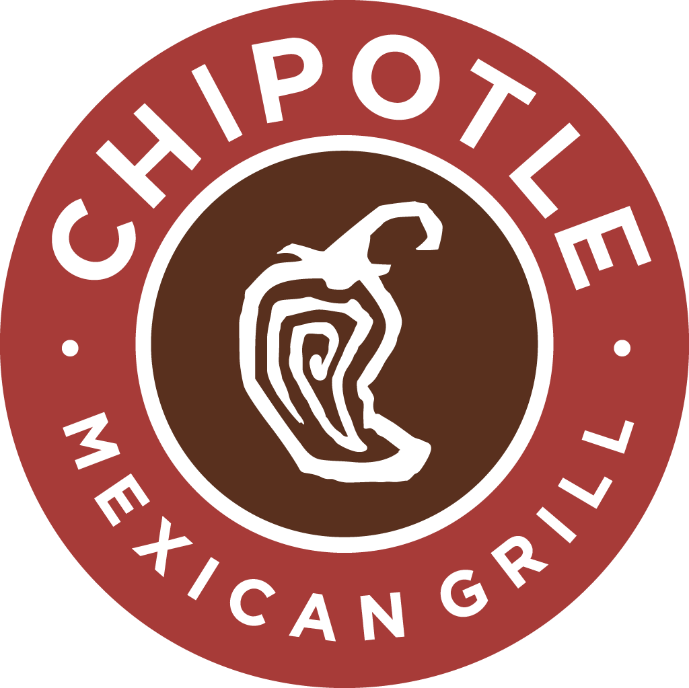
STUDENT NAME

CHIPOTLE MEXICAN GRILL marketing plan

  - Consumer profile CHART
Demographics | Chipotle’s Consumer
Age | 20 to 28 is Chipotle’s targeted age group as this group shares similar beliefs and follow a lifestyle that Chipotle endorses.
Gender | Males and females belonging to this age group are targeted equally.
Occupation | Consumers are putting their education to use by either working at a full-time position or are students working towards one.
Income Level | Income levels of $50,000 to $80,000 would be appropriate to afford a fast-casual meal in Japan, while also being able to satisfy other daily needs.
Ethnicity/Culture | In Japan, Chipotle is focusing on targeting the Asian community as they account for the vast majority of Japan’s population. However, consumers of all ethnicities are welcome.
Stage in Family | These consumers are typically the heads of their household or working towards settling down with a family, and as a result, they are usually responsible for the meal planning in the family.

Psychographics | Chipotle’s Consumer
Personality | The consumers are typically:  - Outgoing  - Classy  - Voice their opinions  - Socially responsible  - Environmental stewards  - Athletes or live active lifestyles
Beliefs/Attitudes/Opinions | Chipotle’s targets consumers who:  - Value the quality of a product over its price  - Are health conscious and follow an active lifestyle  - Do not appreciate added chemicals or artificial flavors to their food  - Prefer a fast-casual setting as opposed to a fast food one  - Support Chipotle’s “Food with Integrity” vision as they value the environment
Lifestyle | Workers with a full-time positon, working typically 8 hours in order to provide for their families. They tend to follow a socially active lifestyle as millennials and support social causes.
Buying Patterns and Behaviors | Chipotle targets wants to direct its attention to regular and loyal consumers. They have made a good impression on these consumers and they are consistently satisfied with Chipotle’s products. They also do not base purchase decisions off climate or income. They instead value the quality of a product as opposed to the price and are loyal to Chipotle’s brand.
Expectations | These consumers have high expectations, as they expect to get what they are paying for. This includes the quality of the food as well as customer service. They also have high expectations for companies to consistently uphold a positive image in society.
Product Use Statistics | Japanese consumers will typically be light to medium users as they have either heard of the brand name or simply not tried the product at all. They will most likely be considered medium to heavy users of other fast food competitors

Geographic’s | Chipotle’s Consumer
Area | Chipotle plans to target citizens of Urban communities and cities in Japan including the likes of Tokyo, Yokohama, and Osaka. Members of the communities are content with spending money, public transportation and eating out at an expensive restaurant more often than not.
Climate | Japan is a rainy and humid country, but experiences short winters in urban cities. As a result, the climate will have little to no effect on Chipotle’s sales. Chipotle is also not a season based meal and Japanese consumers usually do not change eating habits as result of the climate because it is fairly consistent.

  - 4 p’s of marketing
Product  - Demand: There is clearly a demand for fast food as Japan’s fast food market is grew by 2% in 2015. This is because of the reoccurring natural disasters in Japan, resulting in people looking for ways to replace home cooked meals. Japan’s tastes are also changing, as they want to try new cuisines. There is clearly demand here. (Covered in greater detail in business proposal)  - Chipotle offers 65,000 different combinations with its cafeteria line of ingredients allowing for a unique experience every time. Most restaurants cannot say the same.  - A Japanese translation is needed for company branding and the “Mexican Grill” phrase as only 12% of Japan speaks English.  - Chipotle will continue to use brown, orange and red as part of their branding as they are signs of happiness, industrious, and the earth. These align will Chipotle’s beliefs perfectly  - Packaging sizes will be smaller in comparison to the US  - Packaging will continue to be composed mostly of recyclable contents to appeal to our target market  - Similarly, recycling programs will be introduced at every branch as waste management is taken very seriously in Japan  - Chipotle prides the quality of both its ingredients and service, as it sources ingredients that are fresh, healthy and grown with respect for the environment. While most restaurants heat up their food, Chipotle cooks and grills all of their ingredients. | Price  - An average meal on Chipotles menu runs for about $6 to $7 US. This is an appropriate price for a fast-casual restaurant due to increased quality of food and service.  - Chipotle’s target market would be more than willing to pay this price, as they value quality over price, appreciate healthier food choices and enjoy a classy atmosphere. On top of that they have the fitting income to pay for a meal at this price.  - Both direct and indirect fast food competitors have their meals priced around $3 to $4. Chipotle’s slightly higher pricing could turn potential customers away, and to competition. However, Chipotle makes up for these costs with high quality ingredients and service.  - Japan imposes a consumption tax rate of 8% on all goods imported (10% on fruits and vegetables) or produced in Japan. Businesses in Japan must also pay corporate and property taxes, among other taxes.  - Chipotle may also have to continuing sourcing their ingredients from the US, as Japan’s agriculture industry declines.  - These production costs may result in a price increase. However, labour costs in Japan are cheaper, reducing these costs.
Place  - Chipotle’s should begin their expansion in the urban cities of either Japan or Yokohama as they provide the greatest opportunity for growth and building the ideal customer base  - Products will be sold at a local branch in either a mall or popular destination. This could include the Tokyo Station or the Harajuku. These are ideal locations that members of Chipotle’s target market would visit.  - Members not belonging to this targeted group will also occasionally visit the mall, allowing opportunity for Chipotle to expand their target market and continue growing their customer base.  - However, there are multiple competitors in these popular areas and Chipotle may have a difficult time attracting customers who are already loyal to a local restaurant or competitor.  - Hiring a local sales agent is also in Chipotle’s interests. An agent would help guide Chipotle during the early phases and help understand the Japanese market. They could also help in finding the perfect location, advertising and retailing our products.  - The land of Japan will not affect the transportation of the supplies and the product. Instead it’s multiple transportation options will allow for flexibility to ship goods and packaging from around the world. | Promotion  - Chipotle’s marketers will be responsible for spreading the word of Chipotle’s opening and Japan and will attract new consumers through promotional offers.  - Advertisements on social media, bill boards and go buses are the best ways to reach the largest amount of people. Social media use is growing with Chipotle’s target market and transportation is big in Japan so outdoor advertising is ideal. These advertisements will be based around Chipotle’s food with integrity, support for local growers, and superior quality and services. This will surely convince Chipotle’s target market that their product is superior to competitors.  - Word of mouth and publicity was a popular form of advertising for Chipotle in the US and will continue to be in Japan as it is inexpensive and effective. This will done through retweeting and sharing Facebook posts and tweets as they are the most popular forms of social media in Japan.  - Chipotle will also promote their product through sales and coupons early on. This will encourage customers to take advantage of the discounted prices, all while Chipotle slowly starts building their customer base.  - This could also be done through supporting local farms, charities and communities affected by natural disasters. This would build partnerships with these groups that would only benefit Chipotle and help spread the word.

  - ADVERTISEMENT EXAMPLES
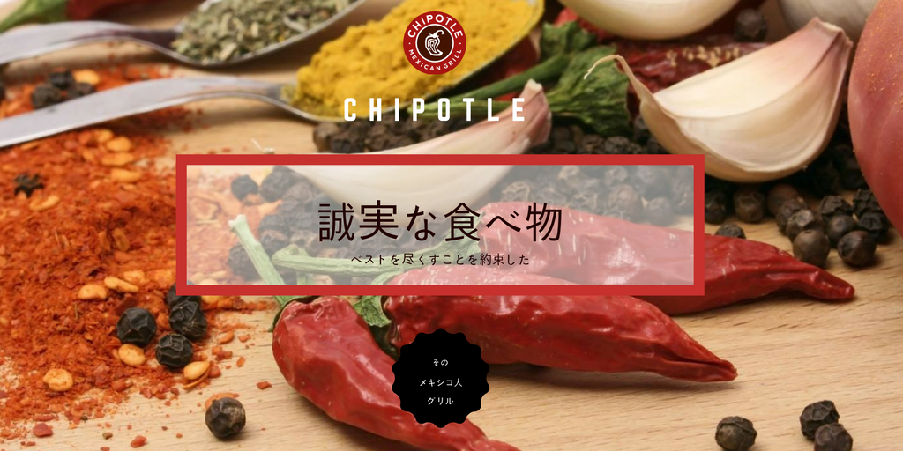
Social Media Example: Created by Ajay

Website Example: http://ajbrar12.wixsite.com/mysite
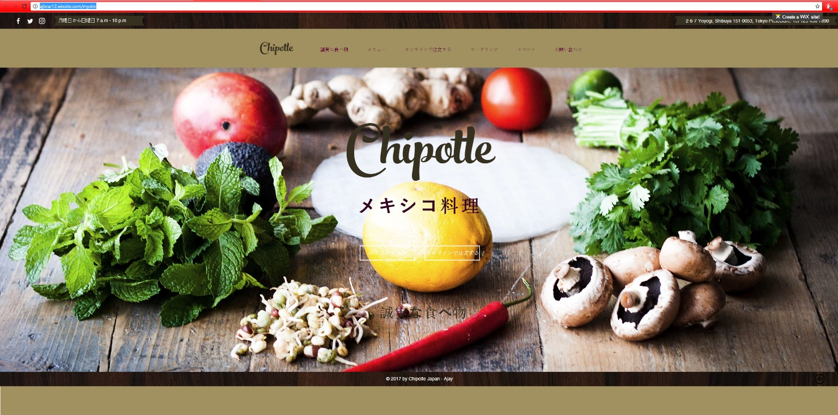
  - REFLECTION
Prior to it’s entry into Japanese market, Chipotle has only dedicated 2% of their income on advertising as they have heavily relied on word of mouth to spread their name. However, this could be an issue in the competitive Japanese market, where many franchise and local restaurants have established a strong customer base with high profile locations. Moreover, most of the Japanese population are non-users and would have to be introduced to the brand with persuasive advertisements. Therefore, I have created two different advertisements; a social media post and web page, both of which attempt to appeal to the traditions and tastes of Japan and Chipotle’s specific target market. For instance, both ads endorse Chipotle’s wide range of ingredients and also include some of Japan’s favorite ingredients such as shiitake mushrooms and medium grain rice. This is the case because the Japanese are known to enjoy the world’s different cuisines and have varying tastes. It also goes on to endorse Chipotle’s food with integrity vision statement as well as their devotion to sourcing the healthiest ingredients. Fittingly, Chipotle’s targets individuals who are environmental stewards and follow a healthy lifestyle and this group of consumers will be pleased to see that Chipotle is looking out for them and shares similar interests and beliefs. This is the first step in building a loyal customer base and spreading the word. Overall, with these advertisements, Chipotle can introduce a new and unique cuisine in Japan, while strategically attracting customers using Japan’s favorite foods and flavors, as well with its mission statement. Similarly, these advertisements are the best way to reach Chipotle’s specific target market. This is due to the reason that social media and the internet advertising is only growing in Japan, while mediums such as television and magazines are becoming obsolete. Accordingly, Chipotle’s targeted millennial population, use social media the most in Japan, particularly Facebook and Twitter. These platforms would be the fastest and most effective way to reach this group directly. This has been taken in to consideration, and these ads have been designed with pictures as opposed to heavy amounts of text, all with the end goal of earning retweets/likes to continue spreading the brand. The same goes for the website designed for Japanese users. Millennials are fairly busy with work and their social lives, so an option is of online ordering is always appreciated. The website also features an elegant and classy look, as well as Chipotle’s “food with integrity” concept, encouraging visitors to share the link amongst friends. Potential consumers will be attracted by the classy and luxurious vibe that Chipotle gives off, in comparison to the fast food alternatives. Although, classified as a fast-casual, the advertising will suggest that Chipotle is superior and a restaurant for the rich. The website goes on to share all of Chipotle’s contact information, menu details as well as events. This is convenient for a new consumer to learn about Chipotle and answer any questions they may have with a click of a button. Overall, both forms of advertising cater to the Japan’s customs, appeal to a specific target market and consider the consumer profile, while being inexpensive and easily accessible.

  - WORKS CITED
Adam Jones. "Who Are Chipotle’s Customers?"? Market Realist, 18 Dec. 2014. Web. 24 Nov. 2016.

Adam Jones. "What Is Chipotle Mexican Grill?" What Is Chipotle Mexican Grill? Market Realist, 18 Dec. 2014. Web. 24 Nov. 2016.

Hunt, Joshua. "Agricultural Aftershocks: How Japan Is Combatting a Decline in Farming - Modern Farmer." Agricultural Aftershocks: How Japan Is Combatting a Decline in Farming. Modern Farmer, 23 Mar. 2016. Web. 27 Nov. 2016.

Springer, Troy. "Chipotle 2.0: The Blueprint for the Future." "Recovery" May Not Just Be about Food Safety. The Motley Fool, 22 Nov. 2016. Web. 27 Nov. 2016.

Sgrignoli, Christian. "Chipotle Is Priced for Perfection." Chipotle Is Priced for Perfection. The Motley Fool, 24 Feb. 2016. Web. 27 Nov. 2016.

Wendy Gabriel. "Chipotle's Sustainable Endeavors." RecycleNation. N.p., 05 July 2013. Web. 26 Nov. 2016.

"Chipotle - Food with Integrity." Chipotle - Food with Integrity. Chipotle, n.d. Web. 25 Nov. 2016.

"Chipotle – Local Grower Support Initiative." Chipotle – Local Grower Support Initiative. Chipotle, n.d. Web. 25 Nov. 2016.

"Chipotle-linked E. Coli Outbreak Over: CDC." CNBC.com. CNBC, 01 Feb. 2016. Web. 26 Nov. 2016.

"US Fast-food Chains Return to Japan amid McDonald’s Backlash." Ft. Kana Inagaki, 3 May 2015. Web. 27 Nov. 2016.

Marketing Charts Staff. "So How Many Millennials Are There in the US, Anyway? (Updated)." Marketing Charts. N.p., 03 May 2016. Web. 26 Nov. 2016.

"9 Examples Of How Chipotle's Word-Of-Mouth Marketing Strategy Works Its Magic - Word-of-Mouth and Referral Marketing Blog." Word-of-Mouth and Referral Marketing Blog. Referral Candy, 07 Sept. 2016. Web. 27 Nov. 2016

